Crash Course Computer Science #4: Representing Numbers and Letters with Binary
Name: |  | Date:

Instructions
Watch Crash Course Computer Science #4: Representing Numbers and Letters with Binary on YouTube first. Then answer the following questions. Try to answer the question without looking at the video, but re-watch the video or parts of it if you cannot remember the answer.
- How many possible values are there in Base-Ten Notation?
- 9
- 10
- 3
- 2
- In decimal notation, the number places are: ones, tens, hundreds, thousands, ten-thousands, etc. What are the first 5 places in the binary notation?
      - ________
      - ________
      - ________
      - ________
      - ________
- Convert the binary number 1100101 to decimal:
___________
- Convert the binary number 1001111 to decimal:
____________
- Convert the number 498 to binary:
_____________________________________
- Convert the number 211 to binary:
______________________________________
- Add these two binary numbers together:
10010
+ 11011
_____________________

- What is the smallest unit of binary data called?
  - Nibble
  - Word
  - Letter
  - Bit
- Complete the table below for prefix names:
Size | Prefix
“million”
“billion”
“trillion”
- How are negative numbers represented in a binary number?
_____________________________________________________________________________________
- What is a floating-point number?
_____________________________________________________________________________________
- How are floating point numbers represented in binary?
_____________________________________________________________________________________

- What was the original standard that dictated how letters could be encoded as digits?
_____________________________________________________________________________________
- How big was the standard (in bits)?
__________
- What was the limitation of this standard?
_____________________________________________________________________________________
- What was the updated, internationally-compatible standard for encoding letters and symbols called?
_____________________________________________________________________________________
- How large is this standard (in bits)?
__________
- Using the table on the next page, write your name in binary:
___________________________________________________________________________________
____________________________________________________________________________________
____________________________________________________________________________________
____________________________________________________________________________________
____________________________________________________________________________________
____________________________________________________________________________________
____________________________________________________________________________________
____________________________________________________________________________________
____________________________________________________________________________________

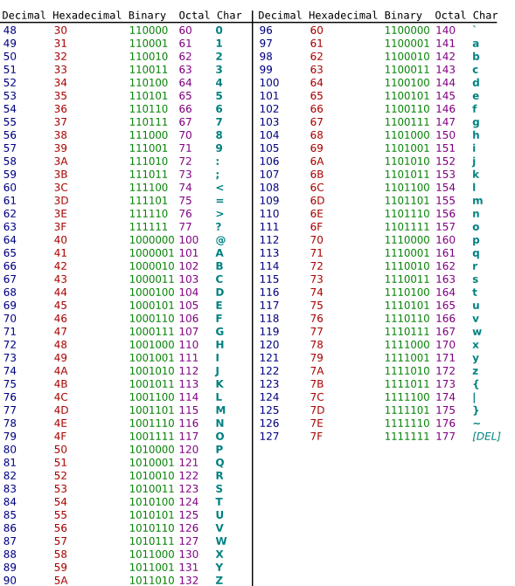

- Complete the Truth Table for XOR:
INPUT A | INPUT B | OUTPUT

- What is “XOR” short for? ________________________________________

- What is the word that means, “using ideas to represent lower layers of detail”?
________________________________________________________________

- Why is the concept of #11 important in Computer Science?
____________________________________________________________________________________________________________________________________________________________________________________________________________________________________________________________________________________________________________________________________

